**LEDP 2020**

Learning and Earning Development Project

MID TERM EXAM - 100 MARKS in 4 hours

**NAME: Md. Zahid Hasan MOB: 01736676622 EMAIL: zh36730@gmail.com REG: 241069 BATCH: WD B-1 Natore LEDP/20**

Questions

1. Create a HTML signature as like as given image - 15 marks

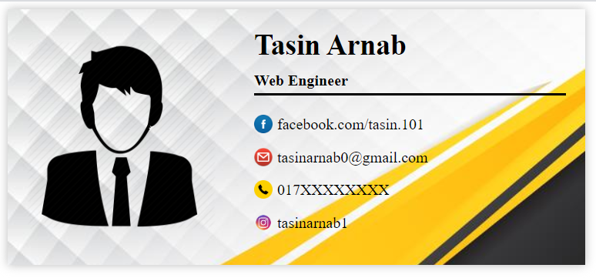

Answer: <https://github.com/Zahid36730/Exam/tree/master/Email%20Signature>

1. Convert Responsive HTML of first three section without menu bar as like as given url (<https://demo.athemes.com/airi-lawyer/>) - 30 marks

Answer: <https://github.com/Zahid36730/Exam/tree/master/HTML%20section>

1. Create a Responsive Slider with Owl Carousel - 15 marks
2. Customize with Lifeline2 theme: as like as <https://sawabbd.org/>

Only Home page which are 7 section (ignore the header and Footer style) - 40 marks

< { [ Tasin Arnab ] } >